**NAME:TASMIYA FATHIMA**

**USN:1BM19CS172**

**PROGRAM-1**

**Queries**

create database insurance;

use insurance;

create table person(

driver_id varchar(10),

name varchar(20),

address varchar(30),

primary key(driver_id));

desc person;

create table car(

reg_num varchar(10),

model varchar(10),

year int,

primary key(reg_num)

);

desc car;

create table accident(

report_num int,

accident_date varchar(20),

location varchar(20),

primary key(report_num)

);

create table owns(

driver_id varchar(20),

reg_num varchar(20),

primary key(driver_id,reg_num),

foreign key(driver_id) references person(driver_id),

foreign key(reg_num) references car(reg_num)

);

desc owns;

create table participated(

driver_id varchar(20),

reg_num varchar(20),

report_num int,

damage_amount int,

primary key(driver_id,reg_num,report_num),

foreign key(driver_id) references car(reg_num),

foreign key(report_num) references accident(report_num)

);

insert into person values('1','tasmiya','kormangala');

insert into person values('2','sosun','wilson garden');

insert into person values('3','masoom','berley street');

insert into person values('4','farhana','landen ');

insert into person values('5','ellen','aradhana layout');

commit;

select *from person;

insert into car values('12','tata','2001');

insert into car values('13','nano','2002');

insert into car values('14','tesla','2003');

insert into car values('15','innova','2004');

insert into car values('16','ford','2005');

commit;

select *from car;

insert into accident values('23','13-12-2012','basvangudi');

insert into accident values('24','14-10-2012','kormangala');

insert into accident values('25','13-06-012','brigade road');

insert into accident values('26','23-05-2012','austin town');

insert into accident values('27','03-01-2012','ring road');

commit;

select *from accident;

insert into owns values('1','12');

insert into owns values('2','13');

insert into owns values('3','14');

insert into owns values('4','15');

insert into owns values('5','16');

commit;

select *from owns;

insert into participated values('12','KA05562','24','5000');

insert into participated values('13','KA07799','25','6000');

insert into participated values('14','KA08899','26','7000');

insert into participated values('15','KA022333','27','8000');

insert into participated values('16','KA03355','27','9000');

commit;

select *from participated;

update participated set damage_amount=25000 where reg_num='KA05562' and report_num=24;

select *from participated;

commit;

insert into accident values('28','18-01-2018','Muesuem road');

select *from accident;

select count(distinct driver_id) CNT from participated a, accident b where

a.report_num=b.report_num and b.accident_date like '%08';

select count(report_num) CNT from car c,participated p where c.reg_num=p.reg_num and

model='ford';

**Screenshots of queries;**

**TABLE PERSON:**

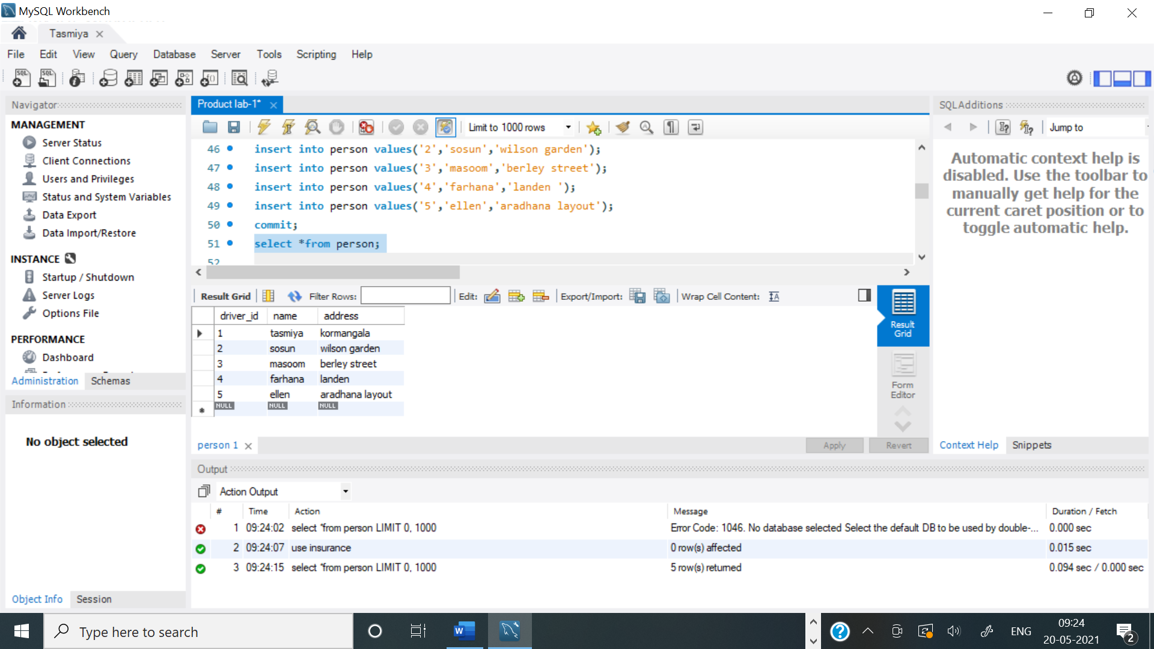

**TABLE CAR:**

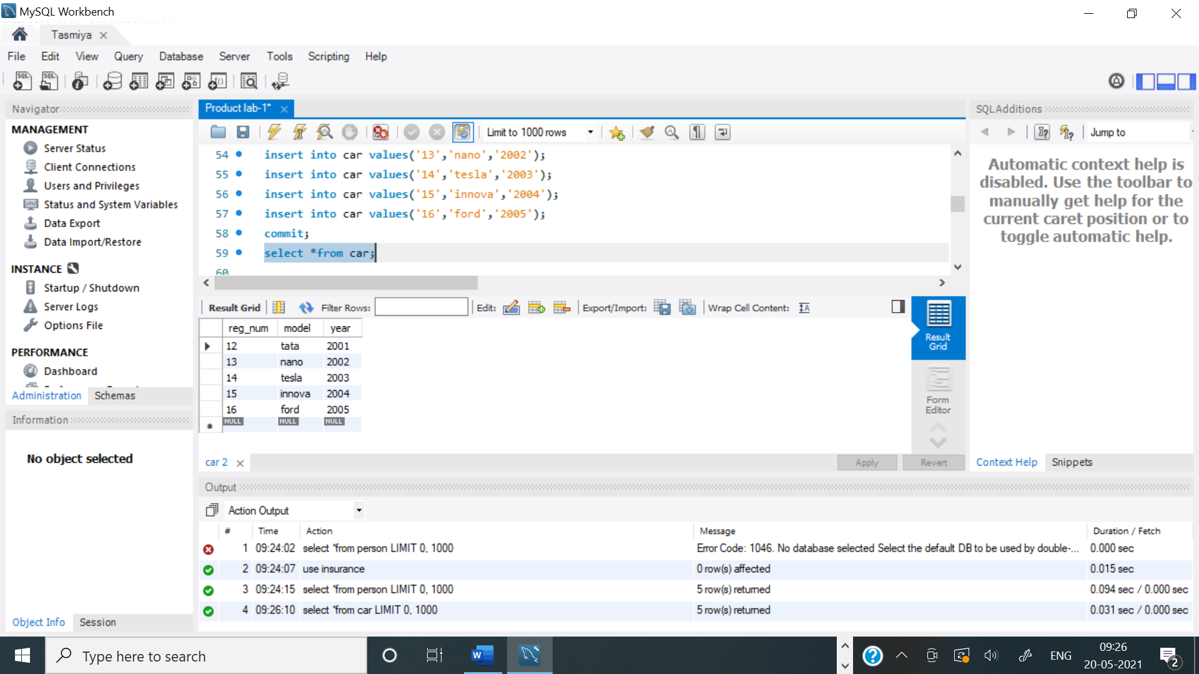

**TABLE ACCIDENT:**

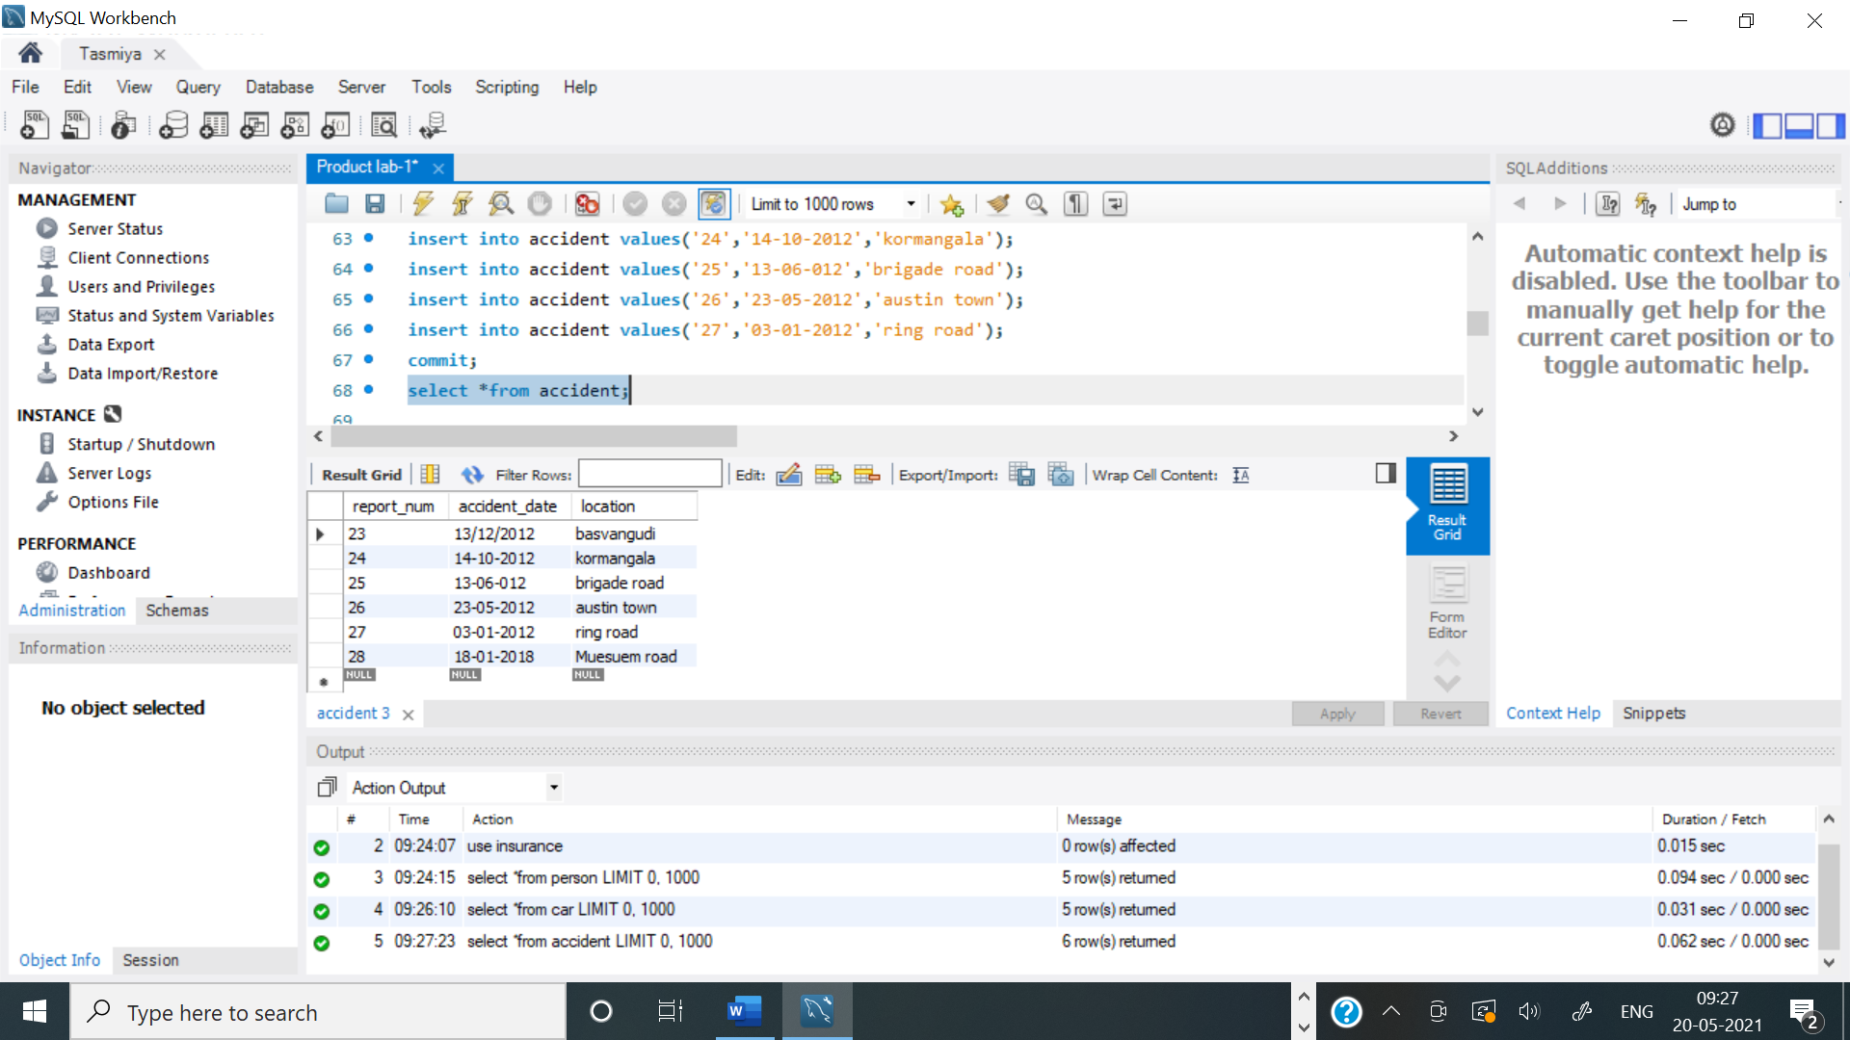

**TABLE OWNS:**

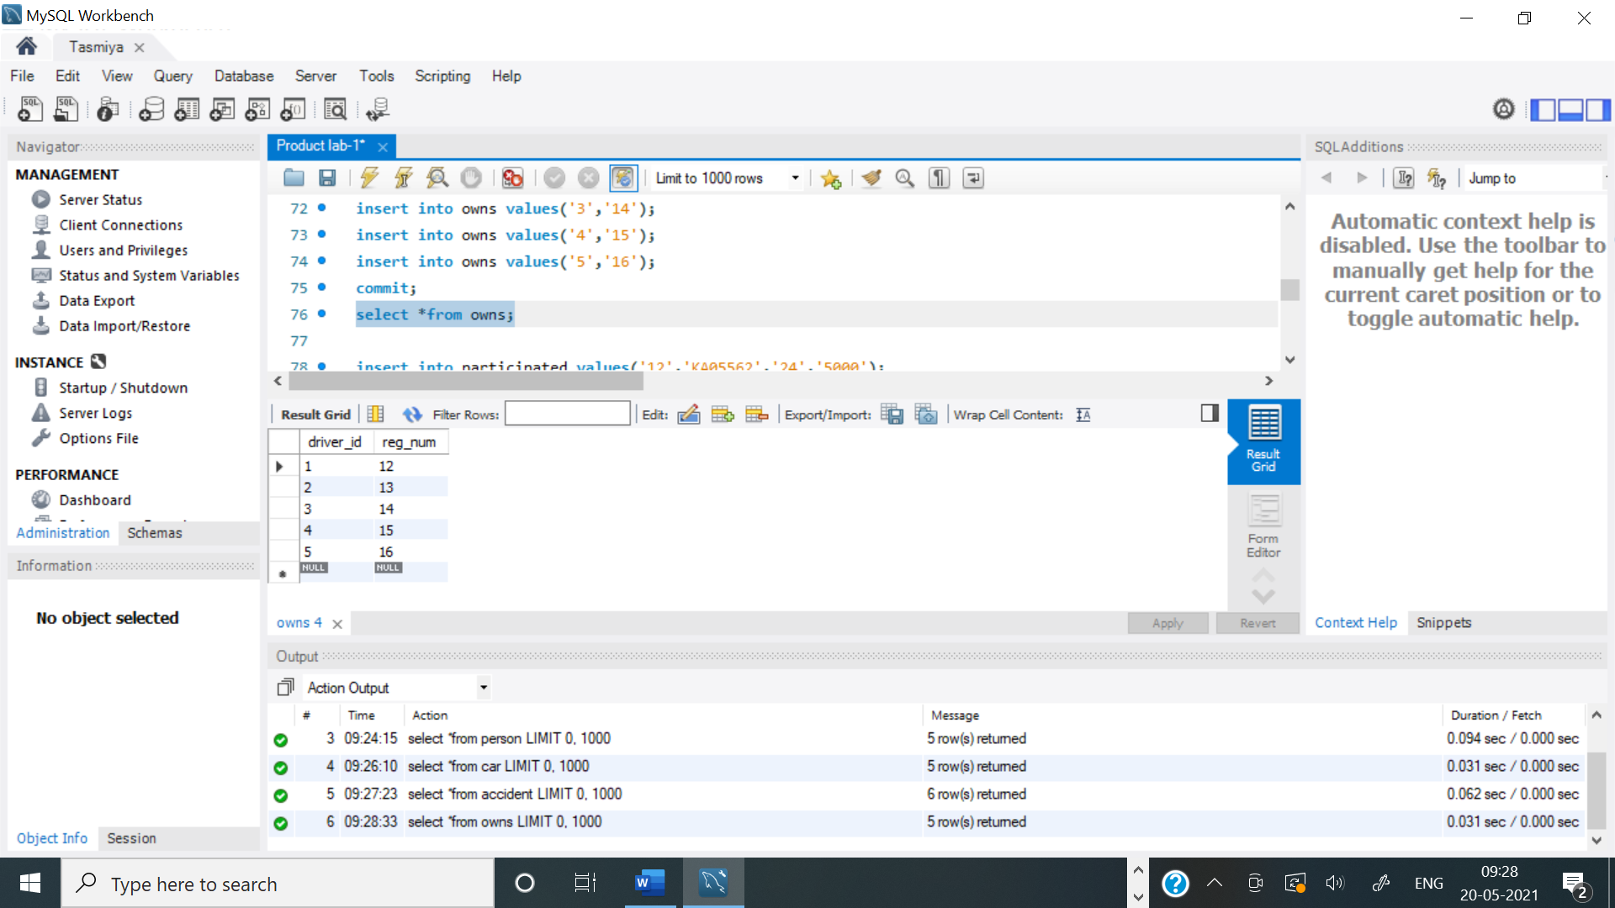

**TABLE PARTICIPATED:**

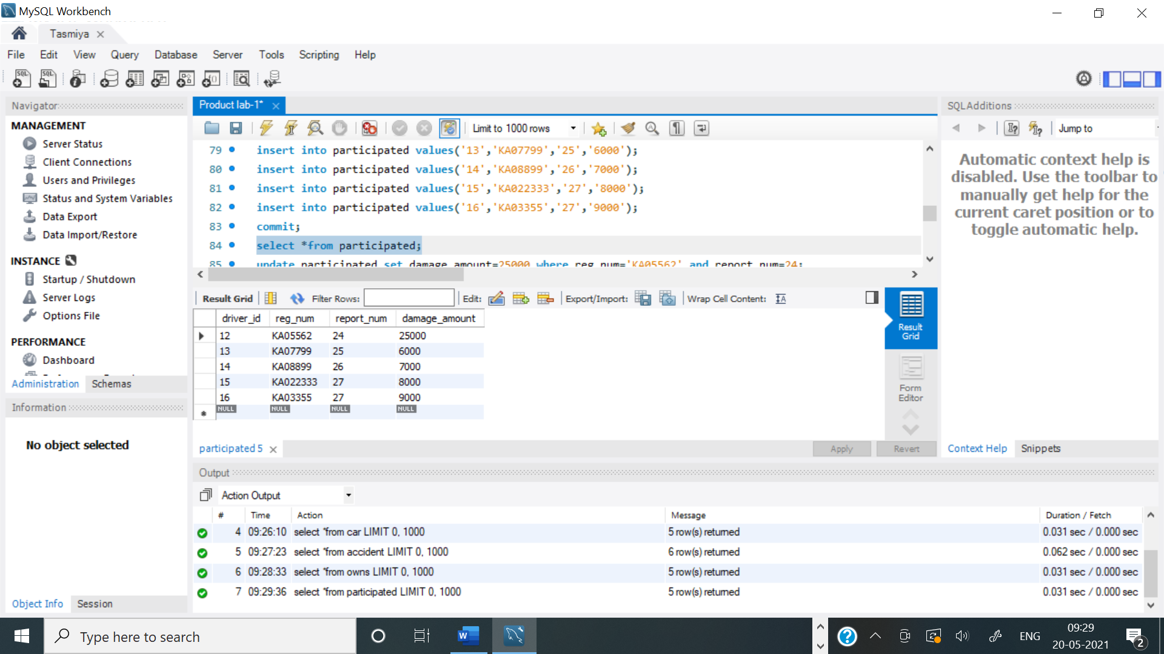

**QUERY 3 a:**

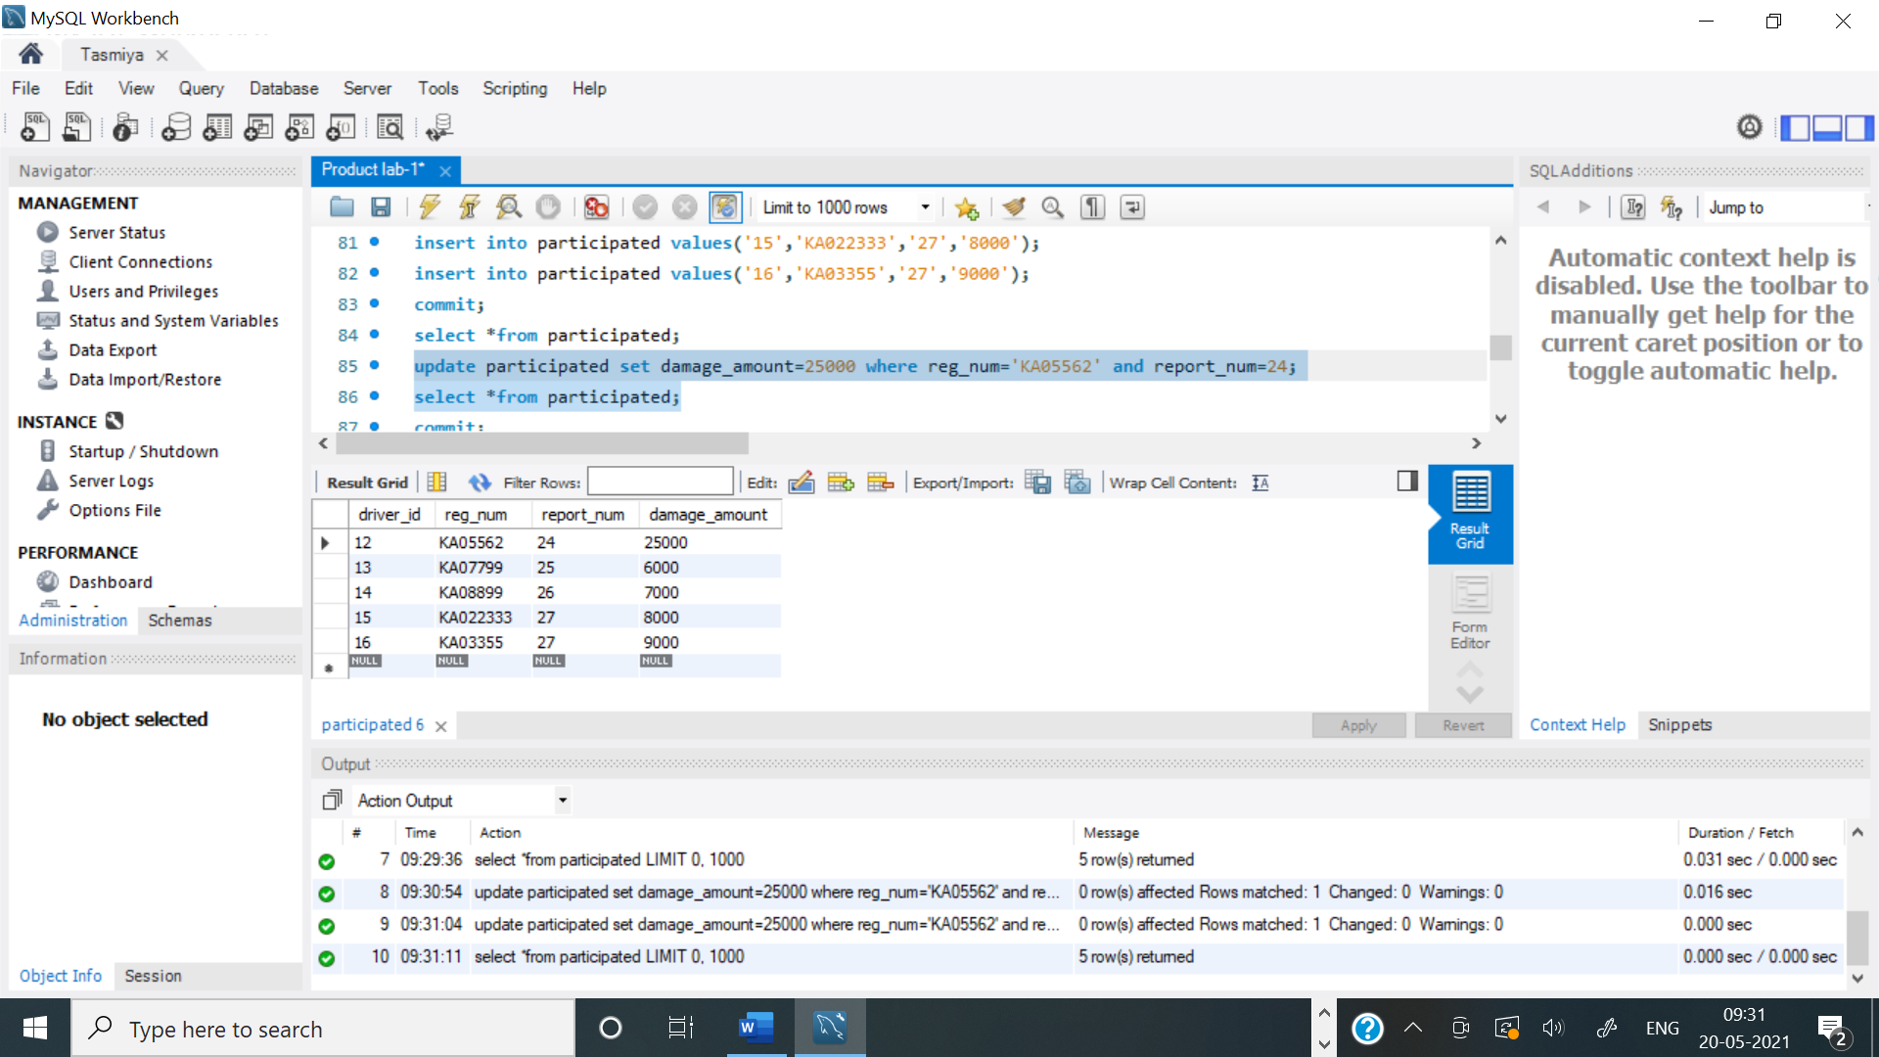

**QUERY 3b:**

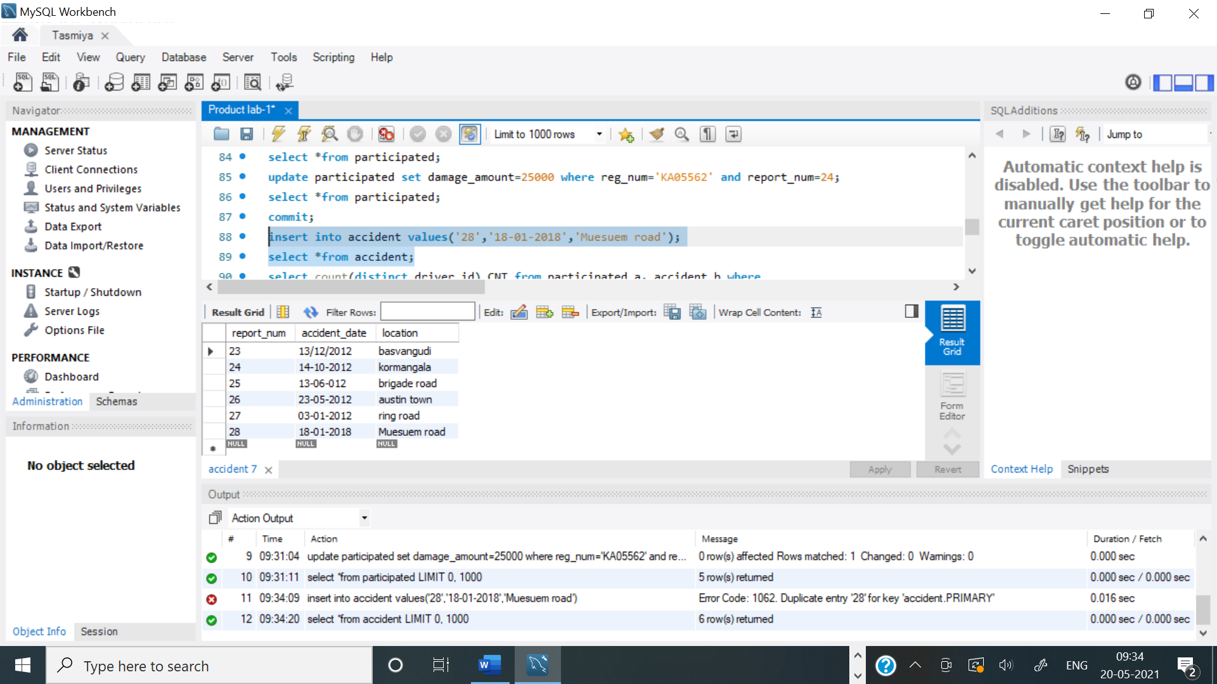

**QUERY 4:**

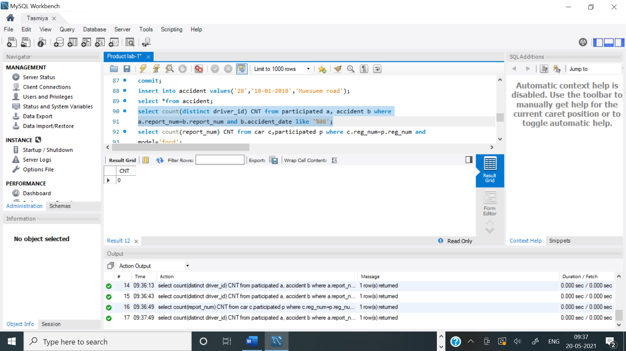

**QUERY 5:**

